SOFTWARE REQUIREMENT SPECIFICATIONS

VIET BOOK ONLINE SHOP

Project: Viet Book Online Shop

Group members: Luan Trinh Khoi

<VERSION 6.0>

# 1/ Introduction.

## Purpose:

This document is used to point out the requirement of the web based online application and give a detail look into the online bookstore system. Each specifications below provides a description for each modules and functions the website is using. This document will also present the functional, non-functional and the required design for the system to be developed.

## Definition, Acronyms and Abbreviations:

* Software Requirement Specification: SRS
* Asterisk mark (*): represents the feature of a value of a control name which cannot be changed or updated. (The symbol is used in most of table descriptions mentioned later on)
* (Required)*: represents a value that the administrator must add into the database and this value cannot be changed nor updated. (used in most of the table description)

## Objective:

The web based application helps the users to buy books through online service by selecting what they want to buy in the listed product from the web pages.

## Scope:

The whole project is developed using Eclipse IDE and managed using Spring MVC.

The application applies a flexible database design which is created by using Hibernate to store the data

Other framework such as Bootstrap and AngularJS are use to develop front-end sites.

The database is managed through the MySQL database.

# 2/ Overall Description.

## Overview:

The whole system works as an online service for selling books. The website will offer a user-friendly layout that helps the user to interact with the sites with ease.

Customers login to the website through their account credentials and their shipping address stored in the database.

## Function:

The system allows users to order books online.

## User Characteristic:

|  |  |
| --- | --- |
| **Users** | **Description** |
| Administrator | Individuals who develop the website, manage the entire application and update the website daily. Have knowledge about Bootstrap, AngularJS and HTML. |
| Customer | People who visit the website to buy products through our online services, he/she can shop with or without an account on our website. |

## Developing Environment:

* Developing tool: Eclipse, Dreamweaver CS6, Photoshop CS6
* Programming language: Java, JavaScript
* Framework: Bootstrap, Angular JS
* Database: MySQL
* Operating system: Window, Tablet, Mobile.

## UML Diagram:

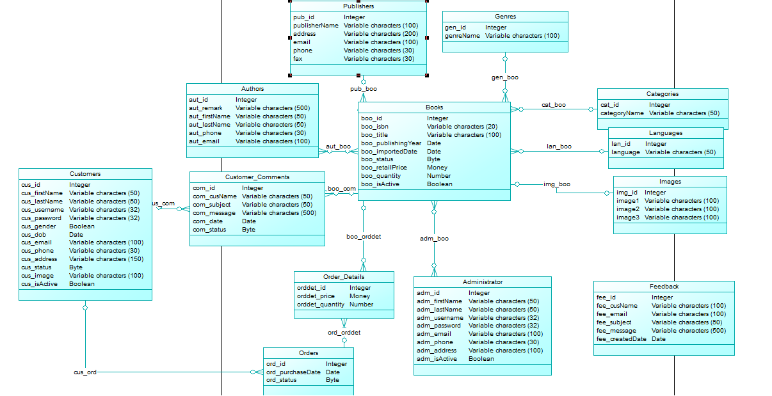

Figure : UML

## 2.6 Entity Diagram:

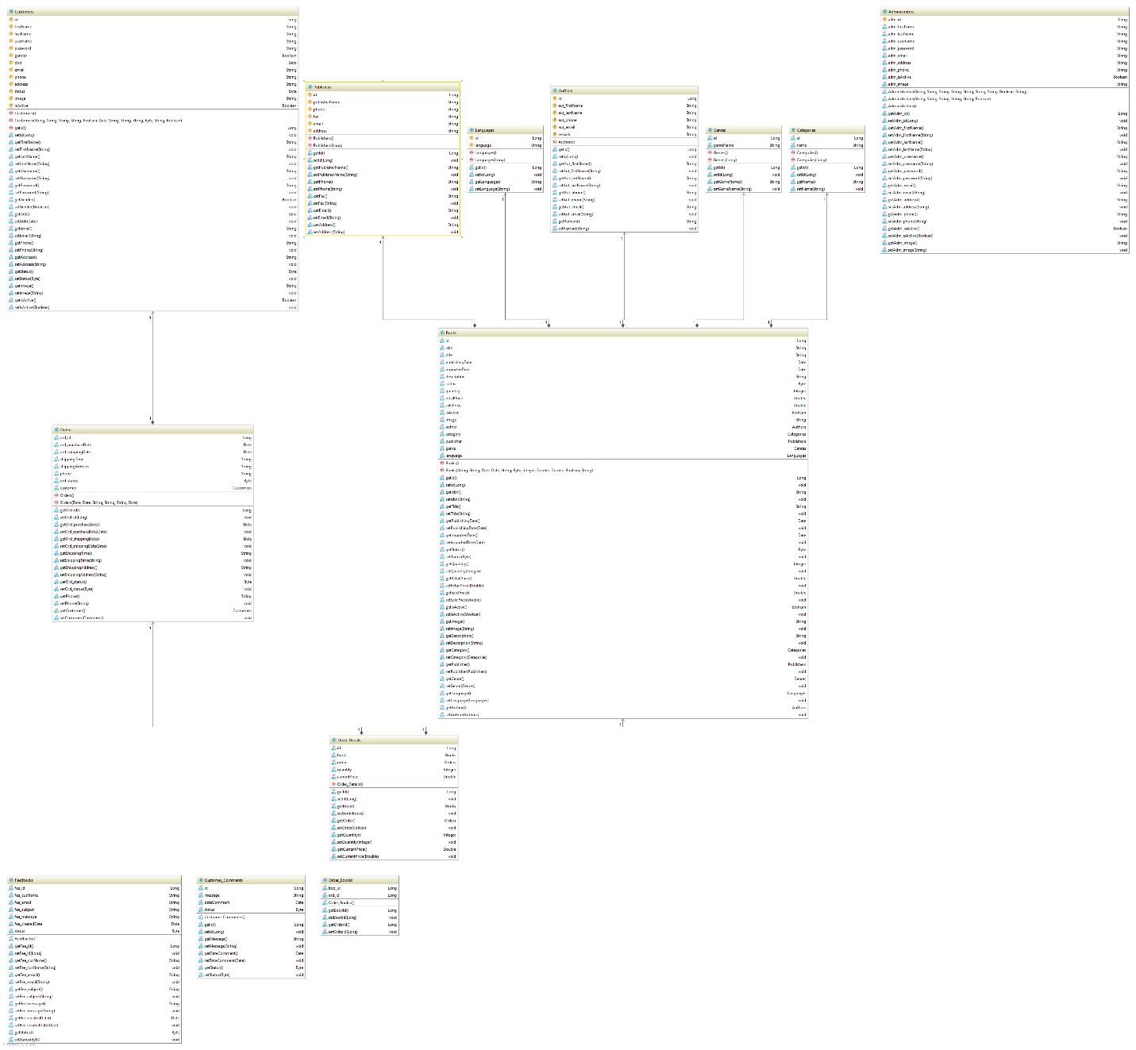

Figure : Entity Diagram

# ADMININSTRATOR SIDE

# 3/ Specific Requirement

## Module 01: Login

## Wireframe:

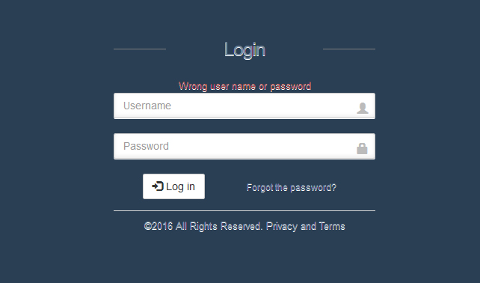

Figure : Login page

## Wireframe Description:

|  |  |  |  |  |
| --- | --- | --- | --- | --- |
| **#** | **Control Name** | **Feature** | **Control Type** | **Description** |
| 1 | Login |  | Label | Website name. |
| 2 | Wrong user name or password |  | Text | Automatically display if certain condition mentioned below is met. |
| 3 | Username | Required | Text | Enter the name of user’s account. |
| 4 | Password | Required | Password | Enter the password.  + **Note**: the password is displayed in * symbols and must be 8 letters above with 1 or more number included. |
| 5 | Login |  | Button | Link to home page.( if the username and password are corrected) |
| 6 | Forgotten password |  | Hyper link | Link the user to the *forgotten* pages. |

## Login Activities:

|  |  |
| --- | --- |
| **Action** | **System Response** |
| Access to the website | Display the login web page |
| Enter username and password |  |
| Press the login button | + ***Step 1***: Check if any of the required fields fit the conditions to connect to the database. (If not, display the error message “Wrong username or password”.)  + ***Step 2***: Once the condition is fulfilled, connect to the database and server.  + ***Step 3***: Verify the user’s information and status through the following conditions:  -*status: active (true)* => Link to home page of the admin site.  -*status: false* => Display message “Username and password is corrected but the account is inactive.”  + ***Step 4***: Move to admin home page. |
| Press the forgotten password button | Lead the user directly to the forgotten password page and proceed to change the password. |

## Login Page Conditions:

|  |  |
| --- | --- |
| **Rules ID** | **Description** |
| R1 | Username and password must not be left blank when login. |
| R2 | If one of the two required field is blank or login unsuccessfully, including wrong password and wrong username, an error message will appear on the screen i.e. *“Wrong user name or password”* . |

## 3.5 Wireframe (Forgotten Password):

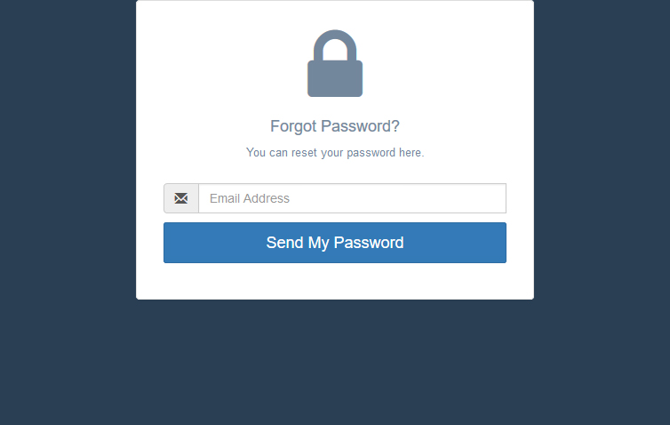

Figure : Forgotten password page

## 3.6 Forgotten Page Description:

|  |  |  |  |  |
| --- | --- | --- | --- | --- |
| **#** | **Control Name** | **Feature** | **Control Type** | **Description** |
| 1 | Forgot Password? |  | Label |  |
| 2 | You can reset your password here. |  | Label |  |
| 3 | Email Address | Required | Email | Enter the email address. |
| 4 | Send My Password |  | Button | A temporary password will be sent to the admin after the system had checked the email address in the admin database is valid. (If the entered email address is correct.) |

## 3.7 Forgotten Page Activities:

|  |  |
| --- | --- |
| **Actions** | **System Response** |
| Enter the admin’s email address into the text box. |  |
| Click “Send My Password” button. | The system will send the admin’s email back to the database then find the username and password of this email.  + **Rule**: If the button is clicked while the email text box is blank or doesn’t follow the correct valid form of an email (**example**: [admin@gmail.com](mailto:admin@gmail.com)), a warning “Please enter a valid email address” will be displayed on the screen and no access is allowed until the text box is entered correctly. |

3.8 Send My Password Cases:

Depending on each cases presented in the table below, the system will response with the appropriate steps when it checks the email address of the admin in the database:

|  |  |
| --- | --- |
| **Cases** | **System Response** |
| The admin’s account is **active.** | + **Step 1**: The system will check the entered email in the admin database to verify through the two following mini cases:   * Case 1: If the address is correct > Proceed to step 2. * Case 2: If the address is incorrect > return the “Error! Please enter the email address again!” message on the screen.   + **Step 2**: Once confirmed, the server will automatically reset the password of the entered email back to **“123abc”**.  + **Step 3**: Send the temporary password back to the admin’s email so they can use it to login and change the new password. |
| The admin’s account is **inactive.** | The system will display the warning message with the following content: “Your account is currently disable, please contact the administrators for more info.” on the screen. |

## Module 02: Admin Homepage

## 3.6 Wireframe:

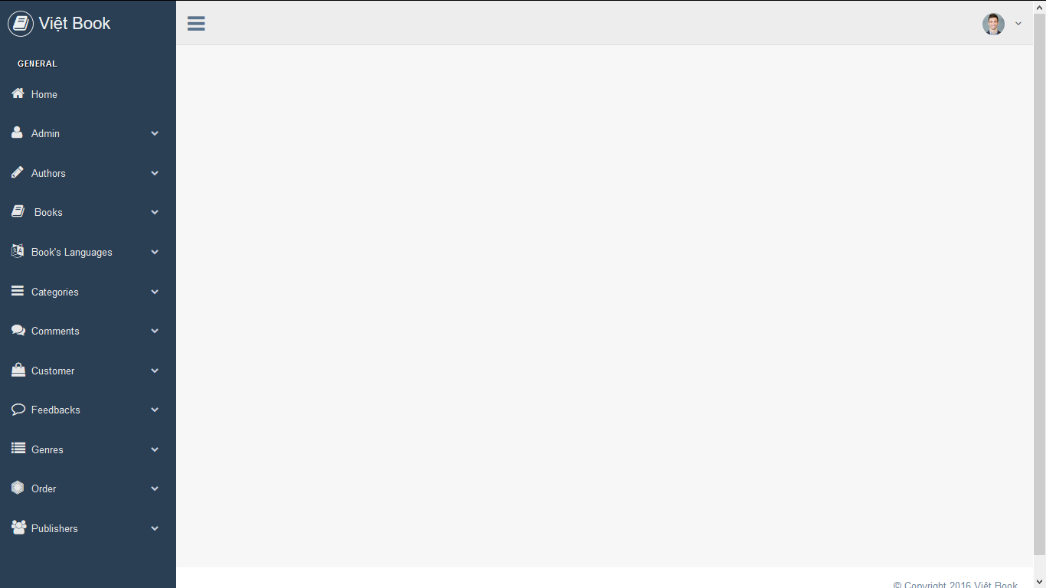

Figure : Admin Home Page

## 3.7 Wireframe Description:

|  |  |  |  |  |
| --- | --- | --- | --- | --- |
| **#** | **Control Name** | **Feature** | **Control Type** | **Description** |
| 1 | Việt Book |  | Label | Website name. |
| 2 | Home |  | Hyperlink | Move to Home page if clicked. (Or refresh the page if the user is already access to the html address.) |
| 3 | Books |  | Toggle Buttons | Set down a list of interacted hyperlinks and leads the admins to the showed address. |
| 4 | Admins |  |
| 5 | Customers |  |
| 6 | Orders |  |
| 7 | Publishers |  |
| 8 | Authors |  |
| 9 | Categories |  |
| 10 | Genres |  |
| 11 | Book’s Languages |  |
| 12 | Feedbacks |  |
| 13 | Comments |  |
| 14 | Images |  |

Table : List of toggle buttons an admin's Home page.

## 3.8 Additional Hyperlinks Description:

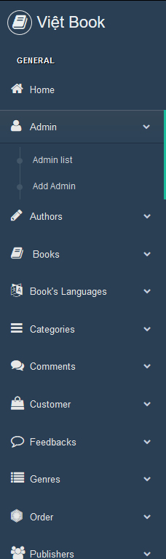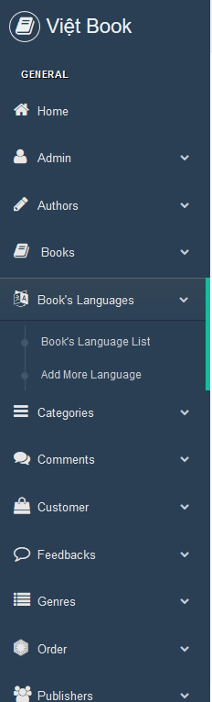

Figure : Additional hyperlinks of each tag.

|  |  |  |  |  |
| --- | --- | --- | --- | --- |
| **#** | **Control Name** | **Feature** | **Controller Type** | **Description** |
| 1 | (Book, Publisher, Author, etc.) List |  | Hyperlink | Move to the List page, where the list and information data of each tag is showed.  + **Note**: The data is editable in these List page. |
| 2 | Add (Book, Publisher, Author, etc.) |  | Hyperlink | Move to the Add Form webpage where the admins must add the new data into the forms in order to store it in the database. |

Table : Description of each hyperlink

+ **Note**: Customers, Orders, Feedbacks, Comments and Images, which receive the values from the client side, only have one additional hyperlinks that lead to their List pages.

## Module 03: Admin Account

## 3.8 Wireframe:

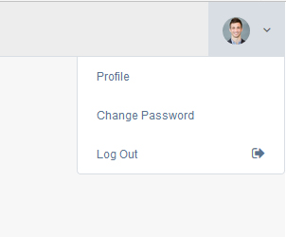

Figure : Admin's account setting display

## 3.9 Account Box Description:

|  |  |  |  |  |
| --- | --- | --- | --- | --- |
| **#** | **Control Name** | **Unique** | **Control Type** | **Description** |
| 1 | Profile |  | Hyperlink | Lead the user to the Account Setting address. |
| 2 | Change Password |  | Hyperlink | Lead the user to the Change Account setting page and let them change the current username or other personal information. (phone, email, address) |
| 3 | Log Out |  | Hyperlink | Exit the admin web page and go back to the login page, disconnecting from the server. |

## 3.10 Wireframe (Admin Profile):

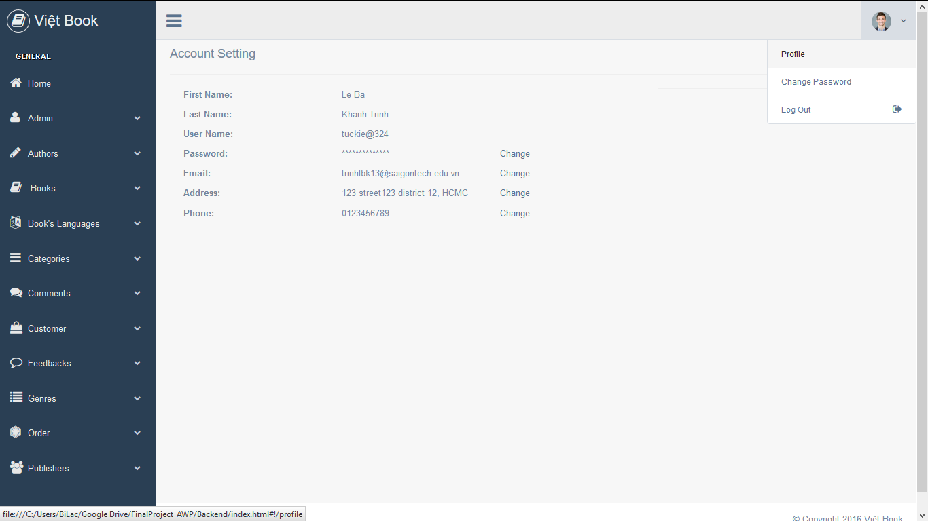

Figure : Administrator's Profile

## 3.11 Wireframe Description:

|  |  |  |  |  |
| --- | --- | --- | --- | --- |
| **#** | **Control Name** | **Feature** | **Control Type** | **Description** |
| 1 | Account Setting |  | Label | Web page name. |
| 2 | First Name | (Required)* | Text | Display the first name of the admin. |
| 3 | Last Name | (Required)* | Text | Display the last name of the admin. |
| 4 | User Name | (Required)* | Text | Display the user name of the admin. |
| 5 | Password | Required | Password | Display the password of the user’s account.  + **Note**: for privacy safety, the password will always appear in the asterisk symbol. |
| 6 | Email |  | Email | Show the email of the user’s account. |
| 7 | Address |  | Text | Show the address of the user. |
| 8 | Phone |  | Text | Show the user’s phone number. |
| 9 | Change |  | Button | Change the login account password, email, address and phone and update the new info into the database. |

## 3.12 Wireframe (Setting):

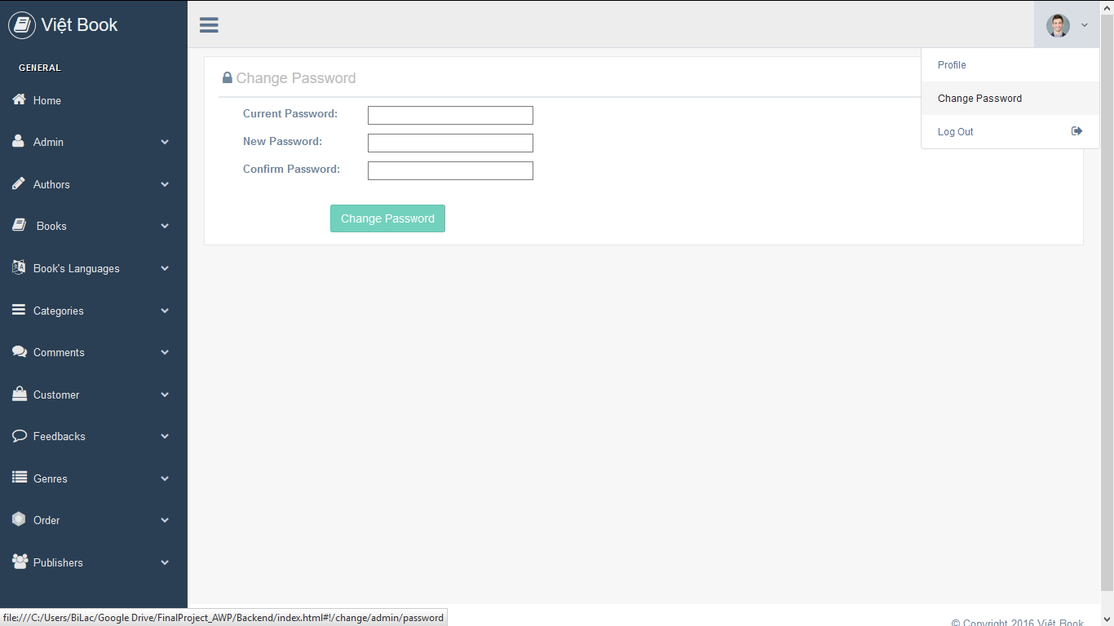

Figure : Administrator's account setting

## 3.13 Account Setting Description:

|  |  |  |  |  |
| --- | --- | --- | --- | --- |
| **#** | **Control Name** | **Feature** | **Control Type** | **Description** |
| 1 | Change Password |  | Label | Web page name. |
| 2 | Current Password | Required | Password | Enter the admin’s current password. |
| 3 | New Password | Required | Password | Enter the new password for replacing the current password. |
| 4 | Confirm Password | Required | Password | Enter the new password again to gain confirmation from the system. |
| 5 | Change Password |  | Button | The new password has been added to the admin database account. |

+ **Change Password** **Condition and Activities**:

To replace the old password and to be able to use the new one, admins are proceed to enter the current password they want to change and the new pass that acts as a replacement for the old one.

By using the double-entry system, upon entering the new password into the textbox, admins must confirm the password again to check if there are any mistake in their typing.

Otherwise, an error message ”Please confirm the password” will display on the screen and the “Change Password” button will be set in a disabled state until all the field have been filled.

## 3.14 Account Setting Activities:

|  |  |
| --- | --- |
| **Action** | **System Response** |
| Enter the current password into the textbox. |  |
| Enter the new password into the textbox. |  |
| Enter the new password again into the confirm password textbox. |  |
| Click the Change Password button. | The system saves the new password into the admin’s account and proceeds to change the current password into a new one after progressing the procedure below with the following steps:  + **Step 1**: the system will check if the new password is matched with one entered in the confirmation text box or not. In this case the steps divides into two possible cases:   * ***True***: if the confirm password *matches* with which entered in the new password textbox >>> goes to step 2. * ***False***: if the confirm password *doesn’t match* with which entered in the new password textbox >>> the system will display an error message “Error! Passwords didn’t match!”, the admin must type the password again.   + **Step 2**: the system will update the password in the administrator’s account, then remove the old password from the database to replace it with the new one. |

## Module 04: Tag Hyperlink (Add Form)

## 3.15 Add New Admin Wireframe:

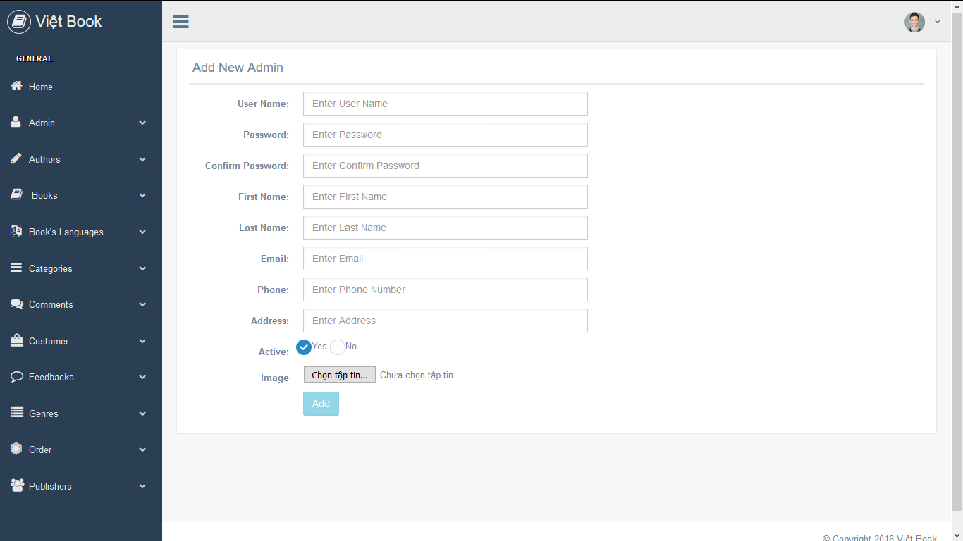

Figure 10: Add Admin Form

## 3.16 Add Admin Description:

|  |  |  |  |  |
| --- | --- | --- | --- | --- |
| **#** | **Control Name** | **Feature** | **Control Type** | **Description** |
| 1 | Add New Admin |  | Label |  |
| 2 | User Name | (Required)* | Text | Enter the desired user name of the new admin. |
| 3 | Password | Required | Password | Enter the password of the new admin.  + **Note**: for privacy protection, this will not be displayed on any public pages. |
| 4 | Confirm Password | Required | Password | Enter the password again for confirmation. |
| 5 | First Name | (Required)* | Text | Enter the first name of the new admin. |
| 6 | Last Name | (Required)* | Text | Enter the last name of the new admin. |
| 7 | Email | Required | Email | Enter the admin’s email address.  + **Note**: for privacy protection, this will not be displayed on any public pages. |
| 8 | Phone | Required | Text | Enter the admin’s phone number. |
| 9 | Address |  | Text | Enter the admin’s address. |
| 10 | Active |  | Radio | Displayed the status of the admin in two cases:  + Yes: The admin is active at the moment or log in.  + No: The admin is inactive or hasn’t logged in the website. |
| 10 | Image |  | Button | Browse the admin image. |
| 11 | Add |  | Button | Add the information of the newly added administrator into the database server and save it there. |

## 3.17 Add Admin Alternative Activities;

|  |  |  |
| --- | --- | --- |
| **#** | **Control Name** | **Activities** |
| 1 | User Name | After the admin had entered their desired user name, the system will perform checking:   * If the entered user name is lower than 4 letters, the system will display a message “*Username must be at least 4 letters*” on the screen. * If the input field of user name is left blank, an advice message “*Please enter the user name*” will appear next to it. * If the entered user name has already existed in the database, the system will stop checking and alarm the user to enter the user name again. * If the entered user name is new, the system will store it in the database.   + **Rule**: A valid user name has pattern: A-Za-z0-9. |
| 2 | Password | The system will check the password after the admin has entered:   * If the password input field is left blank, an advice message “*Please enter the password*” will appear next to the input field. * If the password has already existed in the database, the system will alarm the user to enter the password again.   + **Rule**: the password is displayed in * symbols. |
| 3 | Confirm Password | The system will confirm the password after the admin has entered the input:  _If the input field is left blank, an advice message “*Please confirm the password*” will appear next to the input. |
| 4 | First Name | The system will check the input field after the admin has entered their first name:  _If the input field is left blank, an advice message “*Please enter your first name*” will be shown on the screen. |
| 5 | Last Name | The system will check the input field after the admin has entered their last name:  _If the input field is left blank, an advice message “*Please enter your last name*” will be shown on the screen. |
| 6 | Email | If the admin has entered their email, the system will check:   * If the email input field is left blank, an error message “Please enter your email.” will be displayed on the screen. * If the entered data doesn’t follow the correct valid form of an email (**example**: [admin@gmail.com](mailto:admin@gmail.com)), a warning “*Please enter a valid email address*” will be displayed on the screen. * If the entered email has already existed in the database, the system will alarm the user to verify their email again. |
| 7 | Phone | If the admin has entered their phone number, the system will start checking:   * If the phone input field is left blank, an error message “Please enter your phone number.” will be displayed on the screen. * If the entered data doesn’t fit with the rule below, an error message “*Please enter the numbers only*” will display on the screen. * If the entered phone number is longer than 20 numbers, an error message “*A phone number must has less than 20 numbers*” will appear on the screen. * If the entered phone has already existed in the database, the system will alarm the user to verify their phone number again.   + **Rule**: the phone input field has the maximum length with 10 numbers and must not contain a character. |
| 8 | Address | If the admin want to enter their address, the system will check:   * If the entered address has already existed in the server database, the system alarm the admin to verify their address again. |
| 9 | Image | If the admin click the browse button, a panel will open for the admin to select the image and load it to the database through method POST. |
| 10 | Add | If the admin click the button, the system will begin to perform checking all the information the admin had filled in the administrator form:   * If the required field is left blank or contains invalid value, the button will be set in a disabled state and only become active when all the necessary fields have been filled and the value is corrected. * In addition, if the confirm password input field is unmatched with the data entered in the password input, the “Add” button will be disabled until it’s corrected. * If any of the required value **(not included First name and Last name)** has already existed in the database, the server will stop the checking progress and alarm the admin to verify the entered data again. * Otherwise, the system server will load the new data onto the web service by link and the web service will use the method GET to store the data back in the database. |

## 3.18 Add Authors Wireframe:

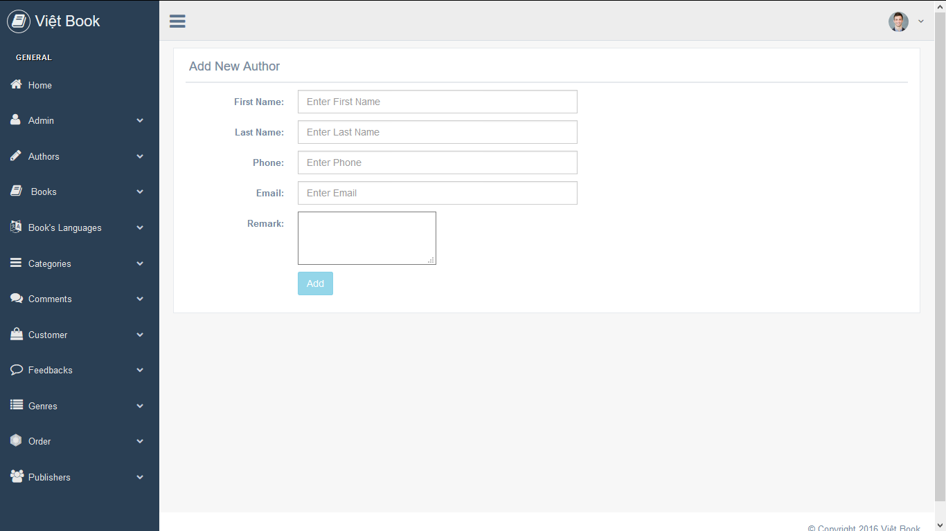

Figure : Add Author Form

## 3.19 Add Author Description:

|  |  |  |  |  |
| --- | --- | --- | --- | --- |
| **#** | **Control Name** | **Feature** | **Control Type** | **Description** |
| 1 | Add New Author |  | Label | Web page name. |
| 2 | First Name | (Required)* | Text | Enter the first name of the author. |
| 3 | Last Name | (Required)* | Text | Enter the last name of the author. |
| 4 | Phone |  | Text | Enter the author’s phone number. |
| 5 | Email |  | Email | Enter the author’s email address. |
| 6 | Remark |  | Text Area | Enter the remarks of the critics or the author themselves about their published books. |
| 7 | Add |  | Button | Add the new information of the authors into the database server and store it there. |

## 3.20 Add Author Alternative Activities:

|  |  |  |
| --- | --- | --- |
| **#** | **Control Name** | **Activities** |
| 1 | First Name | The admin is to fill in the first name of the author and the system will check the entered data. If the input is blank, an error message “Please enter the author’s first name.” will show on the screen. |
| 2 | Last Name | The admin is to fill in the last name of the author and the system will check the entered data. If the input is blank, an error message “Please enter the author’s last name.” will show on the screen. |
| 3 | Add | If the admin click the button, the system will begin to perform checking all the information the admin had filled in the author add form:   * If the required field is left blank or contains invalid value, the button will be set in a disabled state and only become active when all the necessary fields have been filled and the value is corrected. * If any of the required value **(not included the author’s first and last name)** has already existed in the database, the server will stop the checking progress and alarm the admin to verify the entered data again. * Otherwise, the system server will load the new data onto the web service by link and the web service will use the method GET to store the data back in the database. |

## 3.21 Add Book Wireframe:

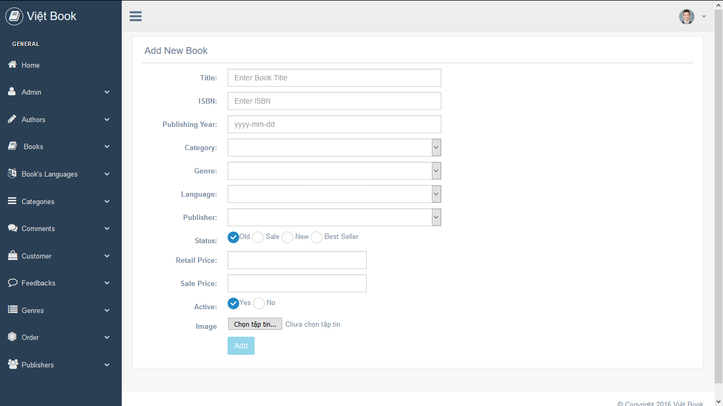

Figure : Add Book Form

## 3.22 Add Book Description:

|  |  |  |  |  |
| --- | --- | --- | --- | --- |
| **#** | **Control Name** | **Feature** | **Control Type** | **Description** |
| 1 | Add New Book |  | Label | Web page name. |
| 2 | Title | Required | Text | Enter the book title. |
| 3 | ISBN | (Required)* | Text | Enter the book ISBN. (International Standard Book Number) |
| 4 | Publishing Year | Required | Date | Enter the date the book is published. |
| 5 | Imported Date | Required | Date | Enter the date the book is imported into the database. |
| 6 | Category | (Required)* | Combo Box | Set down a list of categories when clicked. |
| 7 | Genre | (Required)* | Combo Box | Set down a list of genres when clicked. |
| 8 | Language | (Required)* | Combo Box | Set down a list of languages when clicked. |
| 9 | Publisher | (Required)* | Combo Box | Set down a list of publishers’ name when clicked. |
| 10 | Status | Required | Checkbox | Display the status of the book in four different cases:  + New: the book is published and is only available on the website from recently.  + Sale: the book is having a sale price. + Best Seller: the book that has the highest buyer and visited rate in its description web page.  + Old: the book that has available on the website for more than (3~5) years. |
| 11 | Retail Price | Required | Text | Enter the retail price of the book. |
| 12 | Sale Price |  | Text | Assign the sale price of the book. |
| 13 | Active | Required | Radio | Display the status of the book in two case:  + Yes: available  + No: unavailable |
| 14 | Image | Required | Button | Browse the images of the book. |
| 15 | Add |  | Button | Add the new information of the book into the database server and store there. |

## 3.23 Add Book Alternatives Activities:

|  |  |  |
| --- | --- | --- |
| **#** | **Control Name** | **Activities** |
| 1 | Title | The admin is to enter the title of a book, the system will check the input value:  _If the title input is left blank, the system will display a message “Please enter the book’s title.” on the screen. |
| 2 | ISBN | An ISBN must belong to one book only and cannot be duplicated. Once the admin enters an ISBN, the system will performing a check:   * If the ISBN input field is left blank, an advice message “*Please enter the book’s ISBN*” on the screen. * If the entered ISBN has already been stored in the database, the system will stop checking and alarm the user to enter the ISBN value again. * If the entered ISBN is new, the system will save it into the database. |
| 3 | Publishing Year | Once the admin enters the date the book is published, the system will check the date:   * If the publishing year input field is left blank, the system will display an advice message “*Please enter the published year*” on the screen. * If the entered date is equal or lower than the current day, the system will save it into the database. * If the entered date doesn’t fit with the (yyyy-mm-dd) pattern, an error message “*Invalid date! Please input the date again*” will show on the screen. * If the entered date is higher than the current day, an error message “The date must be lower than the current date” will appear on the screen. |
| 4 | Imported Day | The system will check the entered imported day through the two following cases:   * If the entered data is higher than the current day, the system will display an error “*The date must be lower than the current date*” on the screen. * If the entered date doesn’t fit with the (yyyy-mm-dd) pattern, an error message “*Invalid date! Please input the date again*” will show on the screen. * If the imported day input field is left blank, an advice message “*Please enter the date*” will display next to the field. * If the entered data is lower or equal the current day, the system will proceed to add the value into the database. |
| 5 | Category | The categories in the combo box can be added or edited through the Categories database. |
| 6 | Genre | The genres in the combo box can be added or edited through the Genres database. |
| 7 | Language | The language of the books can be added or edited through the Book’s Language database. |
| 8 | Publisher | The publisher’s name can be added or edited through the Publishers database. |
| 9 | Retail Price | One the admin entered the price, the system will begin to check:   * If the entered price is not a number or having one or more text in between or contains a negative number, the system will alarm the admin with an error message “*Invalid price! Please enter again*” on the screen. * If the retail price input field is left blank, an advice message “*Please enter the retail price*” on the screen. |
| 10 | Image | If the admin click the browse button, a panel will open for the admin to select the image and load it to the database through method POST. |
| 11 | Add | If the admin click the button, the system will begin to perform checking all the information the admin had filled in the book form:   * If the required field is left blank or contains invalid value, the button will be set in a disabled state and only become active when all the necessary fields have been filled and the data is corrected. * If any of the (Required)* data is already existed in the database, the server will stop the checking progress and alarm the admin to verify the entered data again. * Otherwise, the system server will load the new data onto the web service by link and the web service will use the method GET to store the data back in the database. |

## 3.24 Add Book’s Language Wireframe:

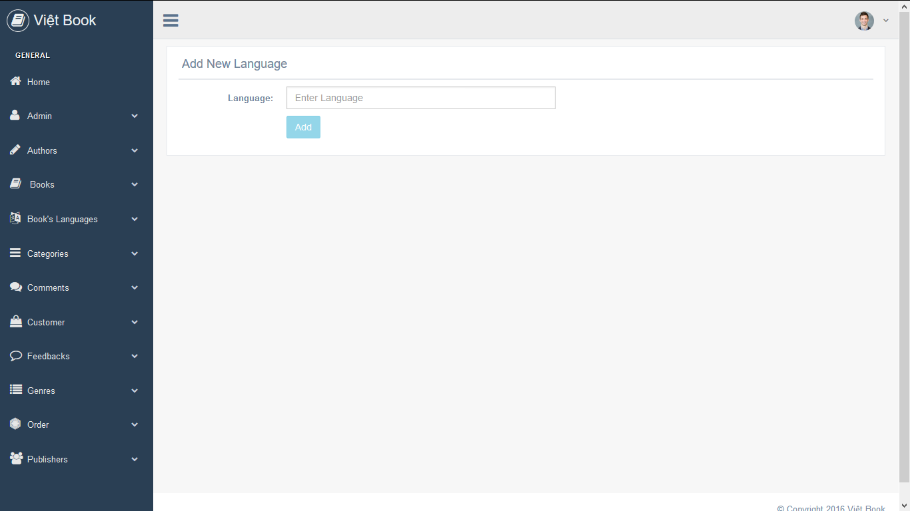

Figure : Add Book Language Form

## 3.25 Add Book’s Language Description:

|  |  |  |  |  |
| --- | --- | --- | --- | --- |
| **#** | **Control Name** | **Feature** | **Control Type** | **Description** |
| 1 | Add New Language |  | Label | Web page name. |
| 2 | Language | Required | Text | Enter the new language for the books. |
| 3 | Add |  | Button | Add the new info into the database server and save it. |

## 3.26 Add Book’s Language Alternative Activities:

1) When the admin enters a new language and adds it, the system will proceed to check the entered data:

* If the language is left blank, the system will display an advice message “*Please enter a language*” on the screen.
* If the data has a number in between text, the system will display an error message “*A language must not contain numbers*” on the screen.
* If the data has already existed in the Language database, the checking process will automatically stop and no more action is taken as the system sent a message alarming the admin that the entered data had been stored in the database.

2) Click the add button, the system will perform the checking with all the entered data in the language add form:

* If the required field is left blank or contains invalid data, the button will be set in a disabled state and only become active when all the necessary fields have been filled and the data is corrected.
* If the language is new and hasn’t been added into the database, the system will load the new data onto the web service by link and the web service will use the method GET to store it in the book’s language data table list and save it.

3) Once added, the system will load the new language from the database to the language combo box in the Book Add form.

## 3.27 Add Categories Wireframe:

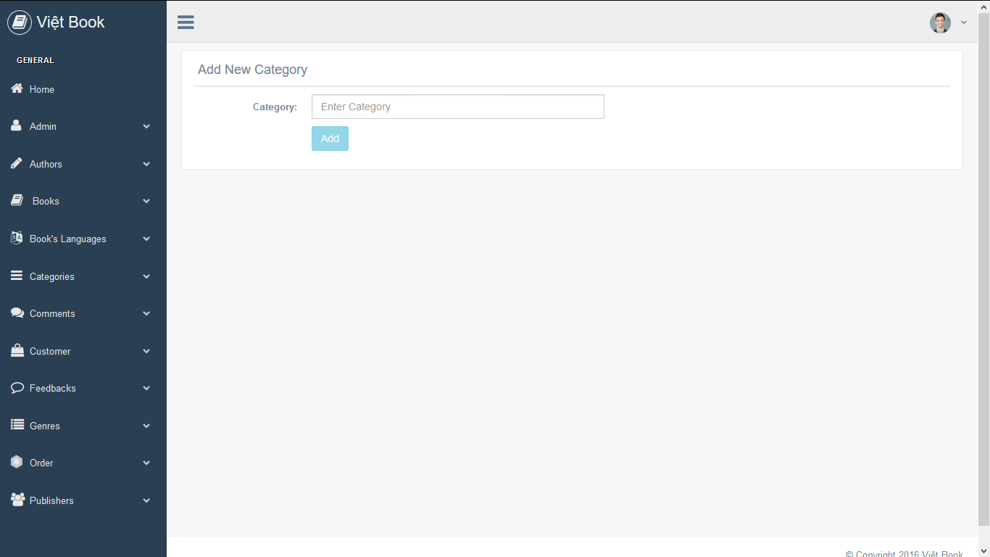

Figure : Add Categories Form

## 3.28 Add Categories Description:

|  |  |  |  |  |
| --- | --- | --- | --- | --- |
| **#** | **Control Name** | **Feature** | **Control Type** | **Description** |
| 1 | Add New Category |  | Label | Web page name. |
| 2 | Category | Required | Text | Enter the category needed for each book to be added in. |
| 3 | Add |  | Button | Add the new category into the database server and store it there. |

## 3.29 Add Categories Alternative Activities:

|  |  |  |
| --- | --- | --- |
| **#** | **Control Name** | **Activities** |
| 1 | Category | If the admin entered a category for the books to be listed in, the system will check:   * If the entered category has one or more number in between text, the system will display the error message “*A category must not contain numbers*” on the screen. * If the category input is left blank, the system will display the message “*Please enter a category*” on the screen. |
| 2 | Add | If the admin click the button, the system will begin to perform checking all the information the admin had filled in the categories add form:   * If the required field is left blank or has invalid input, the button will be set in a disabled state and only become active when all the necessary fields have been filled and the input is corrected. * If one particular category has already existed in the database, the server will stop the checking progress and alarm the admin the category has already been stored. * Otherwise, the system server will load the new data onto the web service by link and the web service will use the method GET to store the data back in the database. * After the new category has been added into the database, the system will load the new stored category into the category combo box in the Book Add form. |

## 3.30 Add Genres Wireframe:

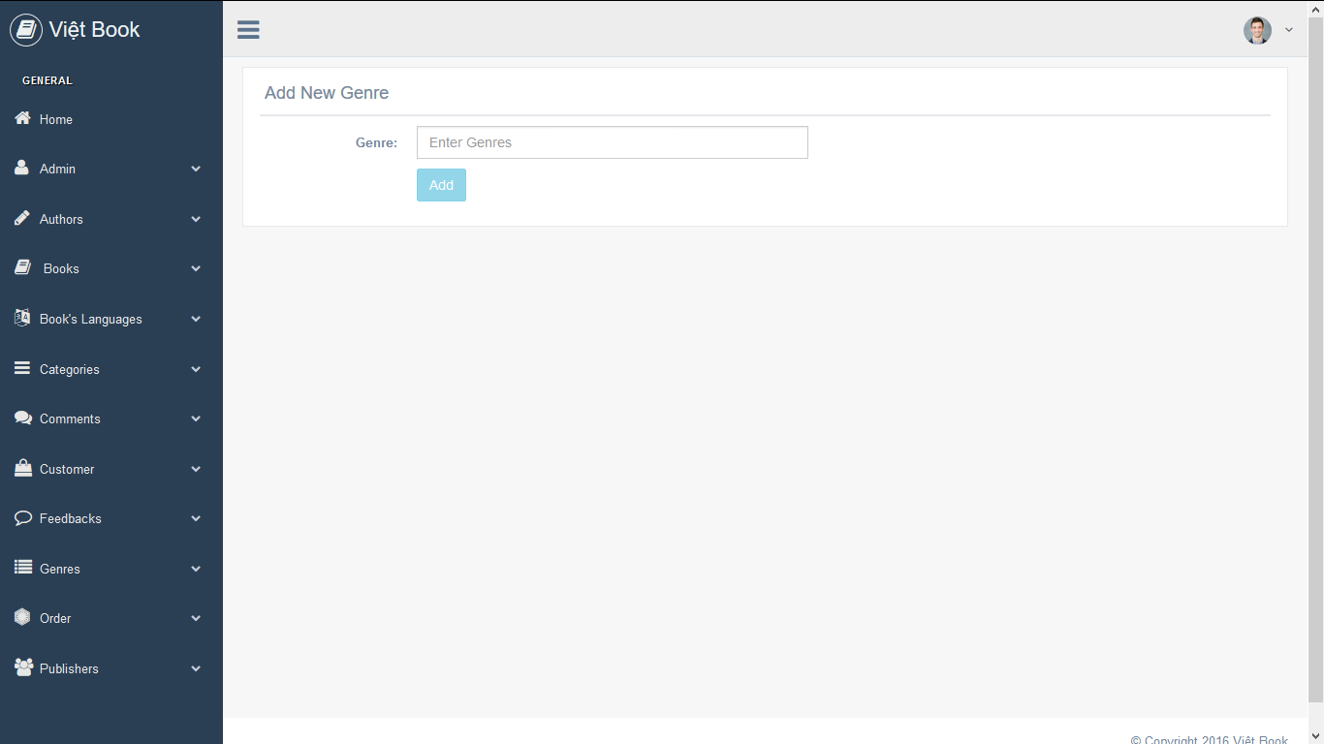

Figure : Add Genres Form

## 3.31 Add Genres Description:

|  |  |  |  |  |
| --- | --- | --- | --- | --- |
| **#** | **Control Name** | **Feature** | **Control Type** | **Description** |
| 1 | Add New Genre |  | Label | Web page name. |
| 2 | Genre | Required | Text | Enter the new genre of the books. |
| 3 | Add |  | Button | Add the new genre into the database server and store it there. |

## 3.32 Add Genres Alternative Activities:

1) Any kind of book required at least one particular genre. After the administrator has entered a genre into the input, the system will check the value:

* If the genre input is left blank, the system will show an error message “*Please enter a genre*” on the screen.
* If the genre input has number in between text, an error message “*A genre must not contain numbers*” will appear next to the input field.

2) Admin clicks the add button, the system will add the new entered genre into the database after checking:

* If the required field is left blank or contains invalid value, the button will be set in a disabled state and only become active when all the necessary fields have been filled and the value is corrected.
* If the required value has already existed, no more process the system will perform and send the above message to the screen to alarm the admin that the value has already been stored in the database.
* If the genre is new and hasn’t been added into the database, the system will load the new data onto the web service by link and the web service will use the method GET to store it into the genre data table list and save it.

3) After a new genre has been added into the database, the system will load the new data into the genre combo box in the Add Book form.

## 3.33 Add Publishers Wireframe:

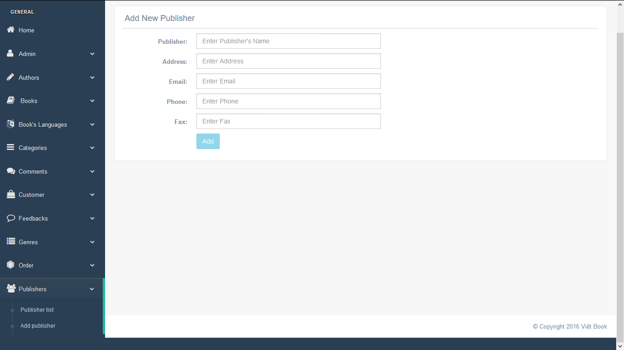

Figure : Add Publishers form

## 3.34 Add Publishers Description:

|  |  |  |  |  |
| --- | --- | --- | --- | --- |
| **#** | **Control Name** | **Feature** | **Control Type** | **Description** |
| 1 | Add New Publishers |  | Label | Web page name. |
| 2 | Publisher | (Required)* | Text | Enter the new of the book’s publisher. |
| 3 | Address | (Required)* | Text | Enter the address of the publisher. |
| 4 | Email | (Required)* | Email | Enter the email of the publisher. |
| 5 | Phone | Required | Text | Enter the phone number of the publisher. |
| 6 | Fax |  | Text | Enter the fax number of the publisher. |
| 7 | Add |  | Button | Add the new information of the publishers into the database server and store it there. |

## 3.35 Add Publisher Alternative Activities:

|  |  |  |
| --- | --- | --- |
| **#** | **Control Name** | **Activities** |
| 1 | Publisher | If the admin entered the name of the publisher, the system will check:   * If the entered name of the publisher has already been stored in the database, the system will stop the checking process and alarm the admin to verify the name again. * If not, the system will store the name into the data table list of Publisher. * If the publisher input field is left blank, an advice message “*Please enter the publisher’s name*” will appear on the screen. * If the entered publisher name is lower than 4 letters, the system will display a message “*Publisher must be at least 4 letters*” on the screen. |
| 2 | Address | If the admin entered the address of the publisher, the system will proceed to perform the checking:   * If the address has already existed in the database, the checking process will automatically stop and admin must enter another address again. * If the input is left blank, an error message “*Please enter the address*” will appear on the screen. * If the entered address has not added in the database, the system will store the address into the data table list of Publisher. |
| 3 | Email | If the admin has entered the publisher’s email, the system will check:   * If the email input is left blank, an error message “*Please enter your email*” will be displayed on the screen. * If the entered address doesn’t follow the correct valid form of an email (**example**: [admin@gmail.com](mailto:admin@gmail.com)), a warning “*Please enter a valid email address*” will be displayed on the screen. * If the entered email has already existed in the database, the system will alarm the admin to verify the publisher’s email again. |
| 4 | Phone | If the admin has entered the publisher’s phone number, the system will start checking:   * If the phone input is left blank, an error message “*Please enter the phone number*” will be displayed on the screen. * If the phone input has one or more characters in between numbers, the system will display an error message “*Please enter the numbers only*” on the screen. * If the entered phone number is longer than 20 numbers, an error message “*A phone number must has less than 20 numbers*” will appear on the screen. * If the entered phone has already existed in the database, the system will alarm the user to verify the phone number again.   + **Rule**: the phone input field has the maximum length with 10 numbers and must not contain a character. |
| 5 | Add | If the admin click the button, the system will begin to perform checking all the information the admin had filled in the publisher add form:   * If the required field is left blank or contains invalid value, the button will be set in a disabled state and only become active when all the necessary fields have been filled and the value is corrected. * If any of the required value has already existed in the database, the server will stop the checking progress and alarm the admin to verify the entered data again. * Otherwise, the system server will load the new data onto the web service by link and the web service will use the method GET to store the data back in the database. * After a new publisher’s name has been added into the database, the system will load the new publisher data into the publisher combo box in the Add Book form. |

## Module 05: Data Table List

* **Note:** the following wireframes are the display of all the sample data stored inside the beta version of the database.

## 3.36 Book Data Table List Wireframes:

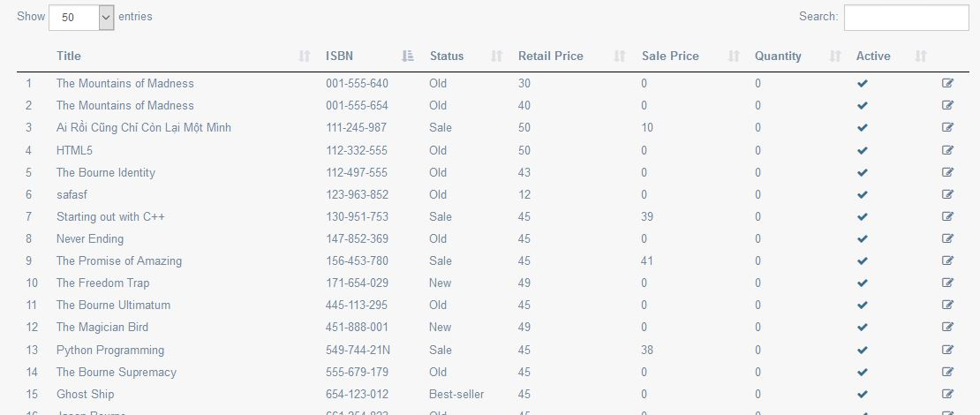

Figure : Book List

|  |  |  |  |  |
| --- | --- | --- | --- | --- |
| **#** | **Column Name** | **Feature** | **Control Type** | **Description** |
| 1 | Title | Required | Label | The book name. |
| 2 | ISBN | (Required)* | Label | The book international standard number. |
| 3 | Publishing Year | Required | Label | The period of time the book was published. |
| 4 | Imported Day | Required | Label | The time the book is imported into the server database. |
| 5 | Status | Required | Label | Book status:  + New: the book was recently published.  + Hot: the book has the highest buying rate.  + Sale: the book is having a sale price.  + Normal: average buying rate and no sale. |
| 6 | Retail Price | Required | Label | The selling price of the book on the website. |
| 7 | Sale Price |  | Label | The sale price of the book. |
| 8 | Quantity | Required | Label | The number of book was sold. |
| 9 | Active | Required | Label | The active condition of one book has two cases:  + Yes: the book is available.  + No: the book is unavailable. |

Figure : Book Data Description

## 3.37 Administrators Data Table List Wireframe:

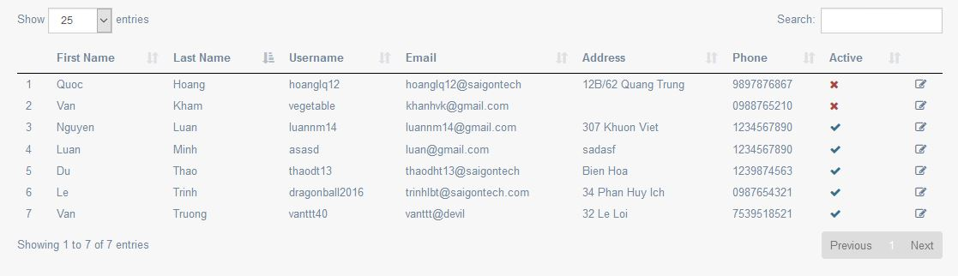

Figure : Administrator List

|  |  |  |  |  |
| --- | --- | --- | --- | --- |
| **#** | **Column Name** | **Feature** | **Control Type** | **Description** |
| 1 | First Name | (Required)* | Label | Admin’s first name. |
| 2 | Last Name | (Required)* | Label | Admin’s last name. |
| 3 | Username | (Required)* | Label | Admin’s desired user name. |
| 4 | Email | Required | Label | Admin’s contacting email address. |
| 5 | Phone | Required | Label | Admin’s phone number. |
| 6 | Address |  | Label | Admin’s home address. |
| 7 | Active | Required | Label | The active condition of the administrator has two cases:  + Check: equal to true.  + Cross: equal to false. |

Figure : Administrator Data Description

## 3.38 Customer Data Table List Wireframe:

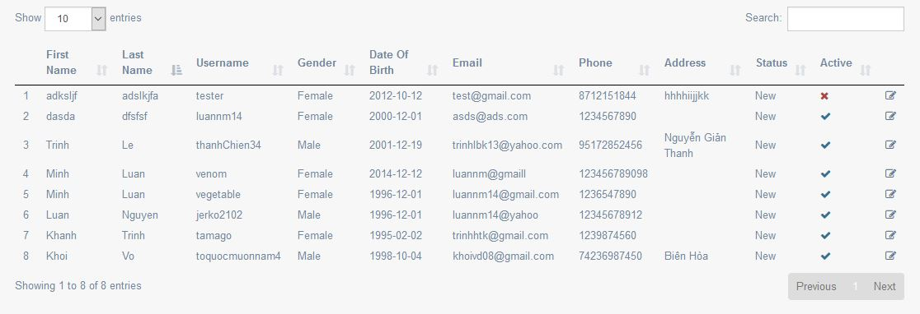

Figure 11: Customer List

|  |  |  |  |  |
| --- | --- | --- | --- | --- |
| **#** | **Column Name** | **Feature** | **Control Type** | **Description** |
| 1 | First Name | Required | Label | Customer’s first name. |
| 2 | Last Name | Required | Label | Customer’s last name. |
| 3 | Username | Required | Label | Customer’s desired account name. |
| 4 | Gender | Required | Label | Customer’s gender: Male or Female. |
| 5 | Date Of Birth |  | Label | Customer’s date of birth. |
| 6 | Email | Required | Label | Customer’s contacting email. |
| 7 | Phone |  | Label | Customer’s phone number. |
| 8 | Address |  | Label | Customer’s home address. |
| 9 | Status | Required | Label | The status of customer’s login account divide into 4 cases:  + New: this account was created recently.  + Normal: this account doesn’t earn any special service from the website.  + Premium: this account has acquired a few special privileges from the website.  + V.I.P: this account earns many special privileges from the website. |
| 10 | Active | Required | Label | The active condition of the customer has two cases:  + Check: equal to true.  + Cross: equal to false. |

Figure : Customer Data Description

## 3.39 Order Data Table List Wireframe:

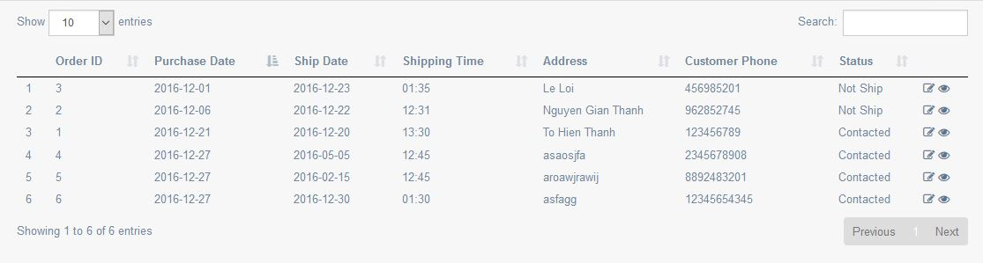

Figure 12: Order List

|  |  |  |  |  |
| --- | --- | --- | --- | --- |
| **#** | **Column Name** | **Feature** | **Control Type** | **Description** |
| 1 | Order ID | (Required)* | Label |  |
| 2 | Customer ID | (Required)* | Label |  |
| 3 | Total Price | Required | Label | Sum of the price of the ordered books. |
| 4 | Quantity | Required | Label | The number of ordered books. |
| 5 | Purchased Date | Required | Label | The period of time the book is purchased. |
| 6 | Ship Date | Required | Label | The time the book is shipped to the customer’s home address. |
| 7 | Address | Required | Label | Customer‘s home address. |
| 8 | Customer Phone | Required | Label | Customer’s phone number. |
| 9 | Status | Required | Label | The status of the order divides into four cases:  + Contact: need to get the confirmation from the customer.  + Not Ship: have not ship the order from the customer.  + Fail: the order is failed (cannot contact customer or customer cancels the order.)  + Success: the order has been shipped to the customer. |

Figure : Order Data Description

## 3.40 Publishers Data Table List Wireframe:

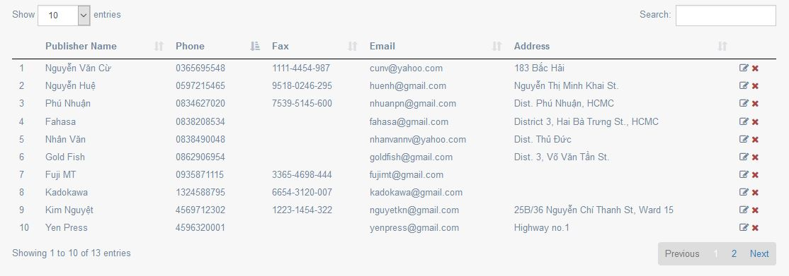

Figure : Publisher List

|  |  |  |  |  |
| --- | --- | --- | --- | --- |
| **#** | **Column Name** | **Feature** | **Control Type** | **Description** |
| 1 | Publisher Name | (Required)* | Label |  |
| 2 | Phone | Required | Label | Publisher’s phone number. |
| 3 | Fax |  | Label | Publisher’s fax number. |
| 4 | Email | (Required)* | Label | Publisher’s contacting email. |
| 5 | Address | (Required)* | Label | Publisher’s address. |

Figure : Publisher Data Description

## 3.41 Authors Data Table List Wireframe:

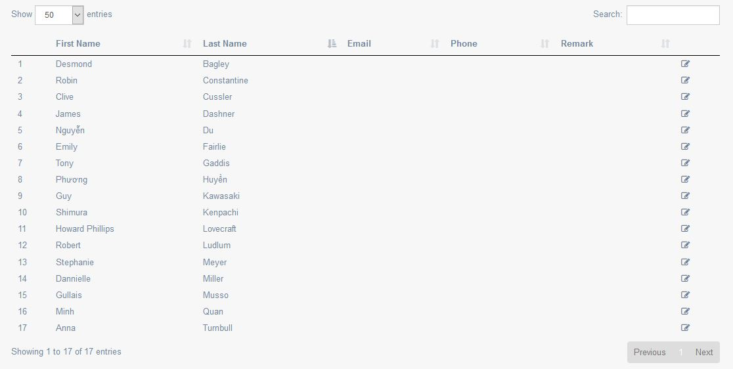

Figure : Author List

|  |  |  |  |  |
| --- | --- | --- | --- | --- |
| **#** | **Column Name** | **Feature** | **Control Type** | **Description** |
| 1 | First Name | Required | Label | The author’s first name. |
| 2 | Last Name | Required | Label | The author’s last name. |
| 3 | Email |  | Label | The author’s contacting email. |
| 4 | Phone |  | Label | The author’s phone number. |
| 5 | Remark |  | Label | The remark of the critics about the author’s works. |

Figure : Author Data Description

## 3.42 Categories Data Table List Wireframe:

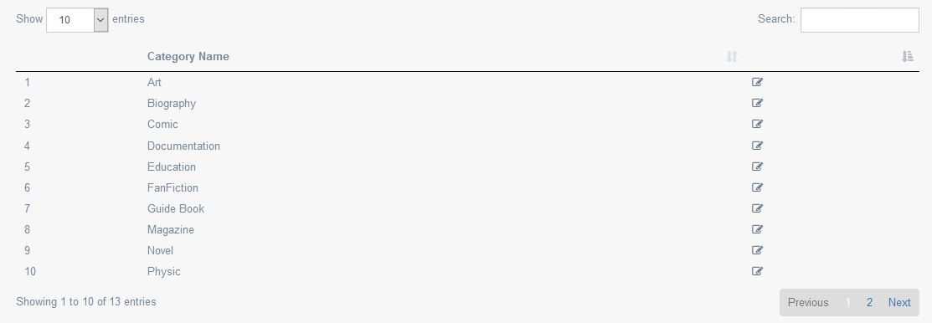

Figure : Category List

|  |  |  |  |  |
| --- | --- | --- | --- | --- |
| **#** | **Column Name** | **Feature** | **Control Type** | **Description** |
| 1 | Category Name | (Required)* | Label | A list of categories which the books belong to. |

Figure : Category Data Description

## 3.43 Genres Data Table List Wireframe:

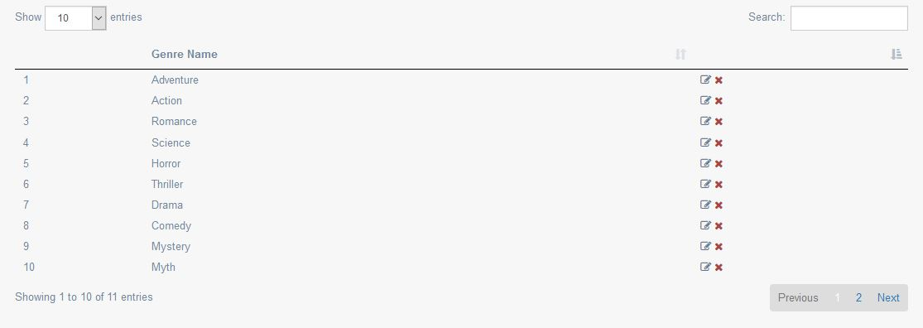

Figure : Genre List

|  |  |  |  |  |
| --- | --- | --- | --- | --- |
| **#** | **Column Name** | **Feature** | **Control Type** | **Description** |
| 1 | Genre Name | (Required)* | Label | A list of genres which the books have. |

Figure : Genre Data Description

## 3.44 Book’s Languages Data Table List Wireframe:

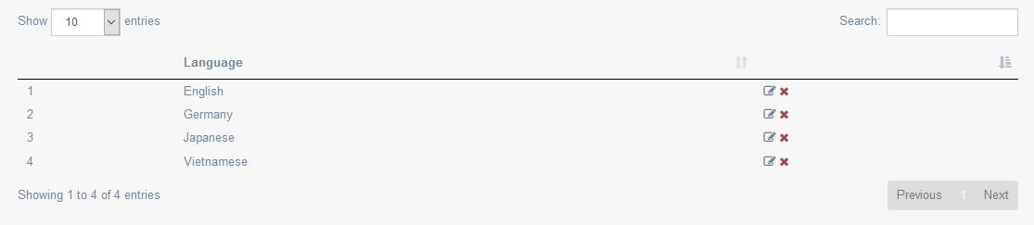

Figure : Book's Language List

|  |  |  |  |  |
| --- | --- | --- | --- | --- |
| **#** | **Column Name** | **Feature** | **Control Type** | **Description** |
| 1 | Language | (Required)* | Label | A list of language in which the books are written. |

## 3.45 Feedbacks Data Table List Wireframe:

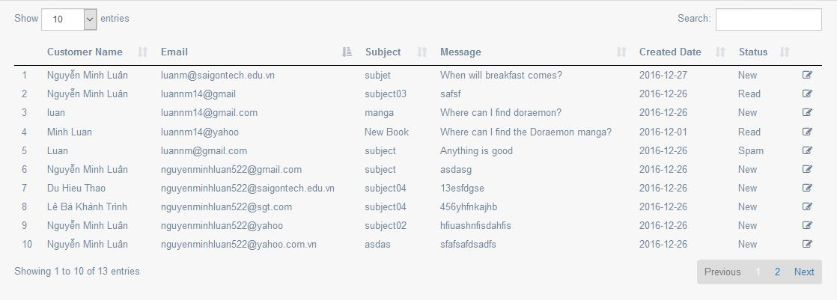

Figure 13: Feedback List

|  |  |  |  |  |
| --- | --- | --- | --- | --- |
| **#** | **Column Name** | **Feature** | **Control Type** | **Description** |
| 1 | Feedback ID | (Required)* | Label |  |
| 2 | Customer Name | Required | Label |  |
| 3 | Email | Required | Label | Customer’s contacting email. |
| 4 | Subject |  | Label | The subject of the feedback sent from the website. |
| 5 | Message | Required | Label | The message, feedback of the customer about the books. |
| 6 | Created Date | Required | Label | The day the database receives the feedback. |
| 7 | Status | Required | Label | The feedback status divides into 4 cases:  + New: the feedback is new.  + Read: the feedback has been read by the admin.  + Spam: the feedback is spam.  + Answered: the admin has answered this feedback. |

Figure : Feedback Data Description

## 3.46 Comments Data Table List Wireframe:

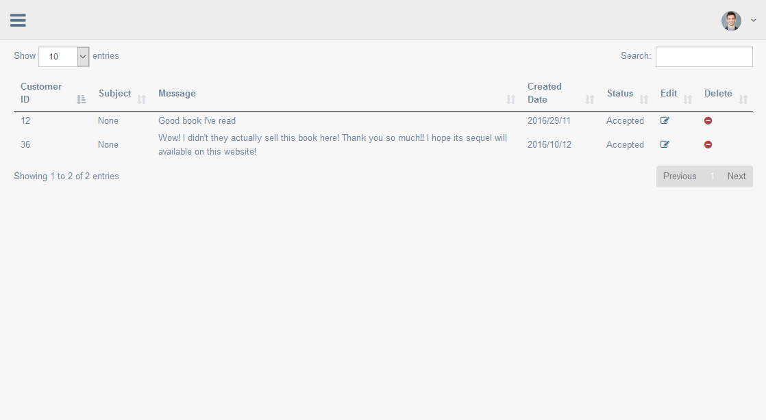

Figure 14: Comment List

|  |  |  |  |  |
| --- | --- | --- | --- | --- |
| **#** | **Column Name** | **Feature** | **Control Type** | **Description** |
| 1 | Customer ID | (Required)* | Label |  |
| 2 | Subject |  | Label | The title of the comment. |
| 3 | Message | Required | Label | The content of the comment. |
| 4 | Created Date | Required | Label | The day the database receives the comment from client side. |
| 5 | Status | Required | Label | Comment status: Accepted or Unaccepted. |

Figure : Comment Data Description

## 3.47 Data Table List Main Function Description:

|  |  |  |  |  |
| --- | --- | --- | --- | --- |
| **#** | **Control Name** | **Feature** | **Control Type** | **Description** |
| 1 |  |  | Select Button | Show the list of entries available on the website data table. |
| 2 | Showing 1 to 2 of 2 entries |  | Label |  |
| 3 |  |  | Button | Sort the data in the table list. |
| 4 | Search |  | Input | Enter a value that needed searching. |
| 5 | Edit |  | Button | Lead the admin to the Edit web page and allow them to edit the value stored in the data table list. |
| 6 | Delete |  | Button | Click the button to delete a row in the data table list. |
| 7 | Previous |  | Button | Return to the previous entry.  (Ex: entry 2 to entry 1.) |
| 8 | Next |  | Button | Go to the next entry.  (Ex: entry 1 to entry 2.) |

## 3.48 All Data Table List Page Activities:

|  |  |  |  |
| --- | --- | --- | --- |
| **#** | **Control Name** | **Activities** | **System Response** |
| 1 |  | Click the select button in the “Show [numbers] entries”. | A list of entries available will appear for the admin to select the entry they want to view. |
| Click at one number. | The data table will switch the current view to the selected entry. |
| 2 | Search | Enter the value the admin want to search in the data table list. |  |
| Press Enter | The system will the entered data and display it on the screen through the following steps:  + **Step 1**: The system will validate the entered data.  + **Step 2**: Send the request from the admin site to the web service.  + **Step 3**: The web service begins searching for the input.  + **Step 4**: display the result on the screen. |
| 3 | Edit | Click the icon button |  |
|  | + The system leads the administrator who wishes to edit the data in the table list to an Edit page where the admin can change the info stored in the data table.  + Using method PUT, the system allow the admin to edit and update the data accordingly. |
| 4 | Delete | Click the delete icon |  |
|  | The system server will initiate the method DELETE to delete the data from the database. |

1. Module 6: Edit Data Function

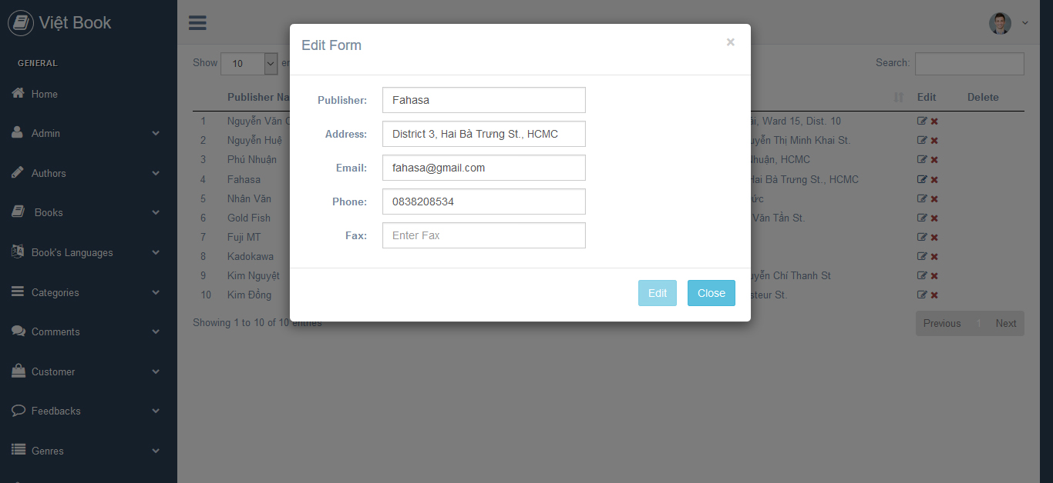In each data table list, the data stored in there can be edited. When the administrator clicks on the edit button in a particular row of data in the database:

Figure : Edit Form

+ An edit form, which contains the information held in that row, will appear on the screen and the admin can edit the info in it. (As showed in figure 32)

+ An edit panel has two buttons: Update and Close.

* If the administrator has edited the info they wanted and clicks on the Update button, the table will update the new info by method PUT.
* If the administrator clicks on the close button, the edit panel will close.

**\*Note**: only the editable data can be edited.

## CLIENT-SIDE

## 4/ Viet Book Requirement:

## Module 1: Home Page

## 4.1 Home Wireframe (Header):

## 

Figure : Home Top Navigation

## 4.2 Home Wireframe Description (Header):

|  |  |  |  |
| --- | --- | --- | --- |
| **#** | **Control Name** | **Control Type** | **Description** |
| 1 | Việt Book | Hyperlink | The website name and a default link that leads to Home page. |
| 2 | Contact | Hyperlink | A link leads to Contact page. |
| 3 | Checkout | Hyperlink | A link leads to Checkout page. |
| 4 | Cart | Hyperlink | A link leads to Cart page. |
| 5 | Login | Hyperlink | A link leads to Login page where user can login the website with their account. |
| 6 | Signup | Hyperlink | A link leads to Signup page where user can create an account for this website online. |
| 7 | Account | Hyperlink | Display the user’s account information through popover window.  (Contains two links that lead to Ordered List page and Account Setting page) |
| 8 | Home | Hyperlink | A link leads to Home page. |
| 9 | Books | Hyperlink | A link leads to Books page. |
| 10 | New Releases | Hyperlink | A Link leads to New Releases page where the new published books are showed. |
| 11 |  | Input | User enters the info which they want to search in the field. |
| 12 |  | Carousel | Slide show, can be switched from image to image. |

## 4.3 Home Wireframe (Right Side):

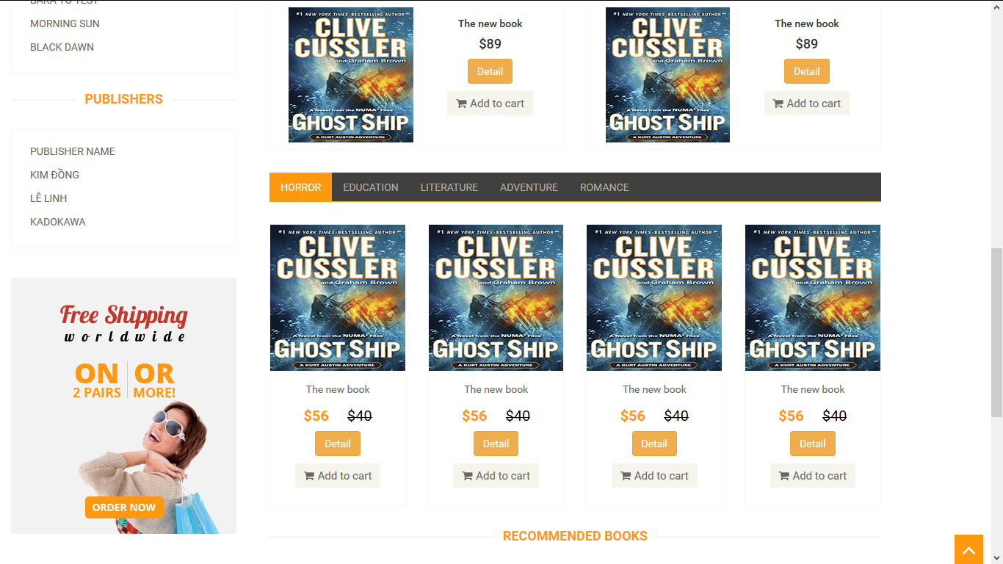

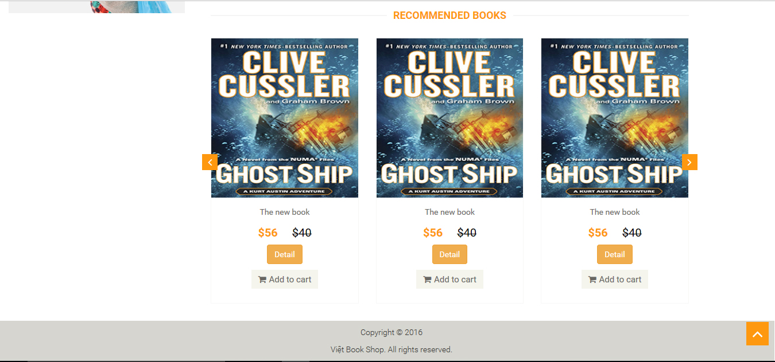

Figure : Home Right Side

## 4.4 Home Wireframe Description (Right Side):

|  |  |  |  |
| --- | --- | --- | --- |
| **#** | **Control Name** | **Control Type** | **Description** |
| 1 | Features Books | Label |  |
| 2 |  | Image |  |
| 3 | The new book | Label | Book Name. |
| 4 | $89 | Label | Book Price (After Sale). |
| 5 | ~~$89~~ | Label | Book Price (Before Sale). |
| 6 |  | Button | Leads the user to Book Description page. |
| 7 |  | Button | Add the book into the shopping cart in Cart page. |
| 8 | (Horror, Education, Literature, etc) | Toggle Button | Switch between categories. |
| 9 | Recommended Books | Label |  |
| 10 |  | Button |  |
| 11 |  | Toggle Button | Move up to the Header of Home page. |

## 4.5 Home Wireframe (Left Side):

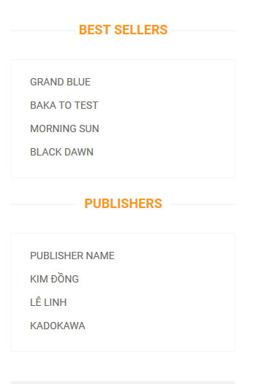

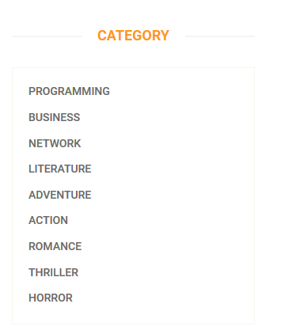

Figure : Home Left Side

## 4.6 Home Wireframe Description (Left Side):

|  |  |  |  |
| --- | --- | --- | --- |
| **#** | **Control Name** | **Control Type** | **Description** |
| 1 | (Category, Best Sellers, Publishers) | Label |  |
| 2 | (Programming, Grand Blue, KADOKAWA) | Hyperlink | _Display the link leads to books detail page  _Display the link leads to the books which were published under the publishers’ name. |

## 4.7 Contact Wireframe:

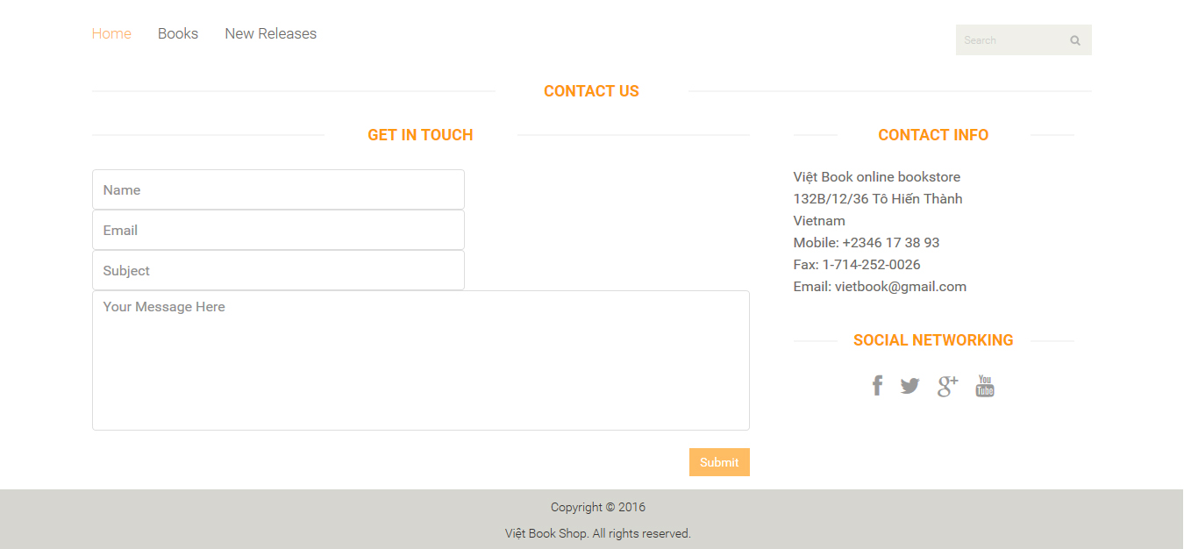

Figure : Contact Page

## 4.8 Contact Wireframe Description:

|  |  |  |  |
| --- | --- | --- | --- |
| **#** | **Control Name** | **Control Type** | **Description** |
| 1 | Contact Us | Label |  |
| 2 | Get In Touch | Label |  |
| 3 | Contact Info | Label |  |
| 4 | Name | Text | Enter user’s name. |
| 5 | Email | Email | Enter user’s email address. |
| 6 | Subject | Text | Enter the subject of the message. |
| 7 | Your Message Here | Text | Enter the message. |
| 8 | Submit | Button | Send the message to the server of the website. |
| 9 | Viet Book online bookstore | Label |  |
| 10 | Social Networking | Label |  |
| 11 |  | Hyperlink | Connecting to social network. |

## 4.9 Contact Form Activites:

|  |  |
| --- | --- |
| **Action** | **System Response** |
| Leave the input fields empty. |  |
|  | While the contact form or any of the required input field doesn’t contain any text, the submit button will automatically remain disable. |
| Enter all the input fields. |  |
|  | If the email contains an input email address that doesn’t fit its pattern, a message “*This email is invalid*” will appear next to the text field. |
| Click the submit button. |  |
|  | The system server will send the message to the administrator.  A message “You have successfully sent the message to us” will appear on top the form to inform the user that their feedback has been sent to the administrator. |

## B. Module 2: Login & Sign up Page

## 4.10 Login Wireframe:

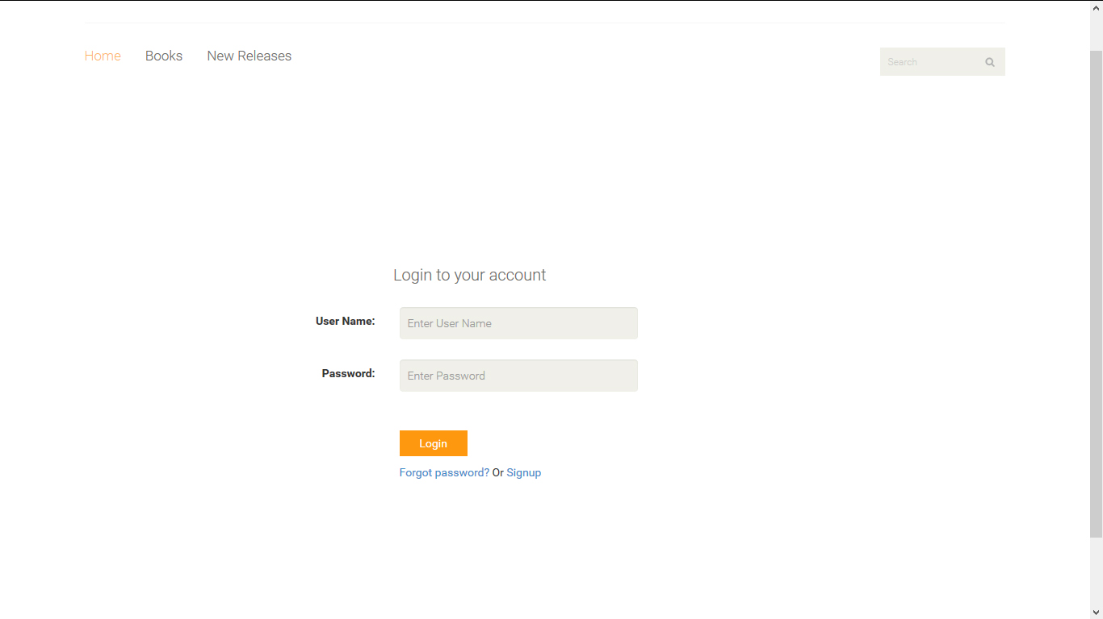4.11 Login Wireframe Description:

Figure : Login Page

|  |  |  |  |
| --- | --- | --- | --- |
| **#** | **Control Name** | **Control Type** | **Description** |
| 1 | Login to your account | Label |  |
| 2 | User Name | Text | Enter the account user name. |
| 3 | Password | Password | Enter the account password. |
| 4 |  | Button | Log in with the entered data. |
| 5 | Forgot password | Hyperlink | Leads the user to the forgotten password page. |
| 6 | Signup | Hyperlink | Leads the user to Sign up page. |

## 4.12 Login Form Activities:

|  |  |
| --- | --- |
| **Action** | **System Response** |
| Any of the two fields is left blank. |  |
|  | A message “*Please enter your (username, password)*” will be showed next to the field to alert the user.  **\*Note:** the login button remains hidden until the entered data in the two fields are corrected. |
| Click the login button. |  |
|  | The system will check the login form:  + If the username and the password are correct > Login the user account  + If one of the two fields is wrong > Display message “Error! Wrong user name or password” |

4.13 Forgotten Password Wireframe:

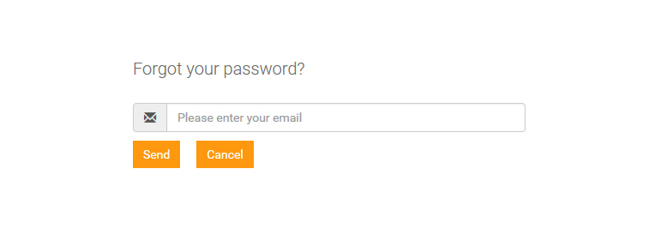

Figure : Forgotten Pass Page

4.14 Forgotten Pass Description:

|  |  |  |  |
| --- | --- | --- | --- |
| **#** | **Control Name** | **Control Type** | **Description** |
| 1 | Forgot your Password | Label |  |
| 2 | Please enter your email | Input | Enter the email address. |
| 3 | Send | Button | Send the email address to the server. |
| 4 | Cancel | Button | Stop the process. |

## 4.15 Forgotten Pass Activities:

|  |  |
| --- | --- |
| **Actions** | **System Response** |
| Enter the user’s email address into the text box. |  |
| Click “Send” button. | The system will send the user’s email back to the database then find the username and password of this email.  + **Rule**: If the button is clicked while the email text box is blank or doesn’t follow the correct valid form of an email (**example**: [user@yahoo.com](mailto:user@yahoo.com)), a warning “Please enter a valid email address” will pop down the text field to alert the user and no access is allowed until the text box is entered correctly. |
| Click “Cancel” button | The system will leads the user back to the Login page. |

## 4.16 Sign Up Wireframe:

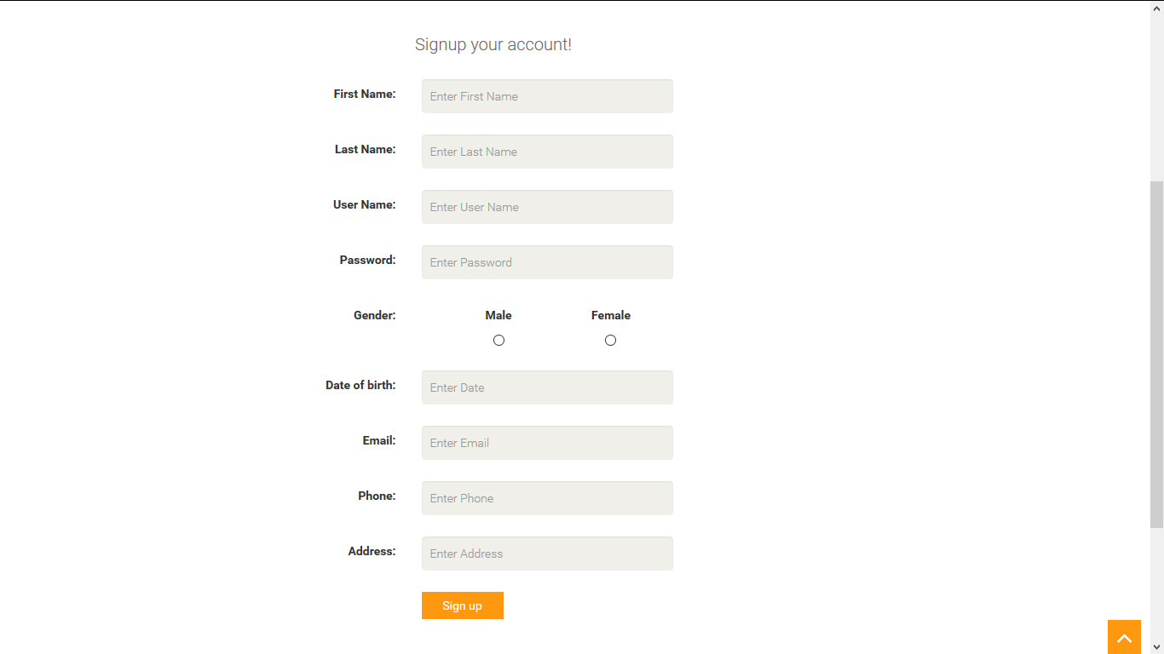

Figure : Sign up Page

## 4.17 Sign up Description:

|  |  |  |  |
| --- | --- | --- | --- |
| **#** | **Control Name** | **Control Type** | **Description** |
| 1 | Signup your account! | Label |  |
| 2 | First Name | Text | Enter the user’s first name. |
| 3 | Last Name | Text | Enter the user’s last name. |
| 4 | User Name | Text | Enter the user’s account name. |
| 5 | Password | Password | Enter the password of the account. |
| 6 | Gender | Radio | Display the gender in two cases:  + Male: Value equal to true  + Female: Value equal to false |
| 7 | Date of birth | Date | Enter the user’s date. |
| 8 | Email | Email | Enter the user’s email address. |
| 9 | Phone | Text | Enter the user’s phone number. |
| 10 | Address | Text | Enter the user’s address. |
| 11 | Sign up | Button | Send the info of the new created account into the database server. |

## 4.18 Sign up Activities:

|  |  |
| --- | --- |
| **Action** | **System Response** |
| Click the “Sign up” button when one or more of the required input fields are left blank. |  |
|  | + A message “*Please enter your (first name, last name, password, etc)*” will appear next to the said fields to alert the user to input the info again before the system can progress.  **\*Note**: During the wrong input, the sign up button remains hidden from view. |
| Click the “Sign up” button when a field doesn’t fit with the desired pattern (example: email should go with the pattern [user@gmail.com](mailto:user@gmail.com)) |  |
|  | + If the user enters an incorrect value in the email input field, a message “*this email is invalid*” will appear next to the field.  + If the user enters an incorrect pattern of the date in the date of birth field, a message “*Please enter in yyyy-mm-dd form*” will appear next to the input field. |
| Click the “Sign up” button when every input field in the form have been entered. |  |
|  | The system server will response with the following steps:  + **Step 1**: The system validates all the input field in the form:   * If corrected > the message “You’ve just signed up successfully” will appear on top the form and the system will proceed to step 2. * If uncorrected > the two messages from the two earlier actions will appear depending on which error the user makes.   + **Step 2**: The system creates a new customer account in the database through method POST.  + **Step 3**: Get all the info in the form and stored it in the newly created account in the database server. |

## 4.19 Account Wireframe (Popover):

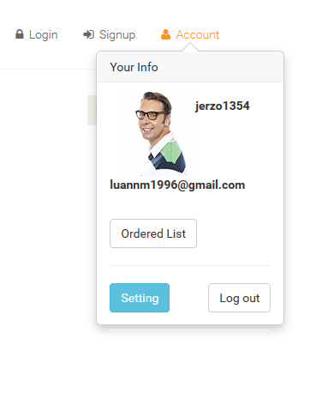

Figure : User's Account Popover Info

## 4.20 Account Description (Popover):

|  |  |  |  |
| --- | --- | --- | --- |
| **#** | **Control Name** | **Control Type** | **Description** |
| 1 | (jerzo1354) | Text | Display the user name of the user’s account. |
| 2 | luan…..@gmail.com | Text | Display the email of the user. |
| 3 | Ordered List | Button | Leads the user to Ordered List page. |
| 4 | Setting | Button | Leads the user to the Account Setting page. |
| 5 | Log out | Button | Log out the account. |

## 4.21 Account Setting Wireframe:

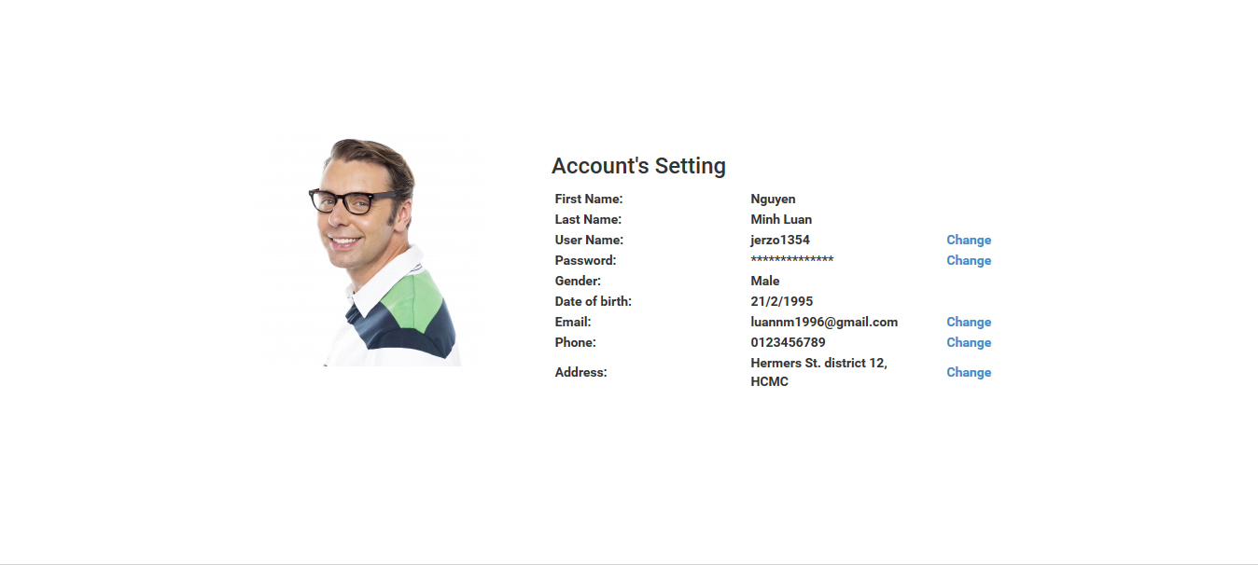

Figure : Account Setting Page

## 4.22 Account Setting Description:

|  |  |  |  |
| --- | --- | --- | --- |
| **#** | **Control Name** | **Control Type** | **Description** |
| 1 | Account’s Setting | Label |  |
| 2 | Change | Button | Edit the info in the user’s account. |

## 4.23 Account Setting Change Function:

|  |  |
| --- | --- |
| **Action** | **System Response** |
| Click at the text “Change” next to any of the shown information |  |
|  | The system will open a small panel with all the info that are allowed to update in their account. If the user makes change to any of the info:  + **Step 1**: The system will update the new info to replace the old one through method PUT.  + **Step 2**: The new info is stored in the data server. |

## 4.24 Ordered List Wireframe:

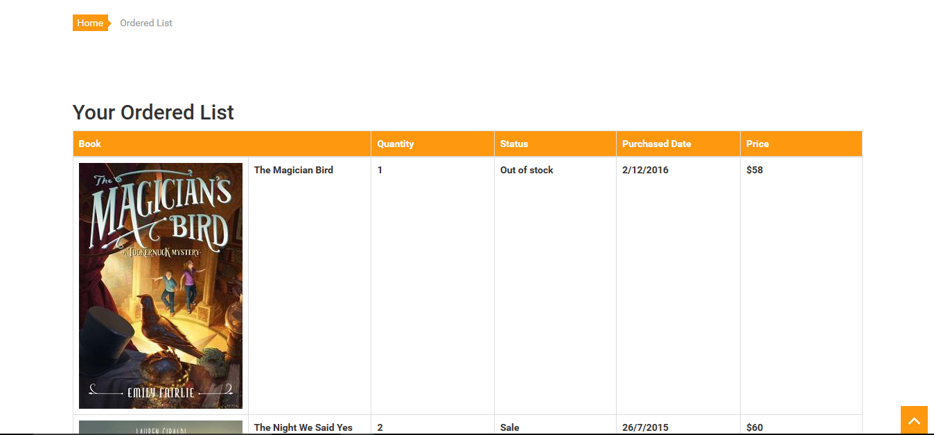

Figure : Ordered List Page

## 4.25 Ordered List Description:

|  |  |  |  |
| --- | --- | --- | --- |
| **#** | **Control Name** | **Control Type** | **Description** |
| 1 |  | HyperLink | Leads back to Home page. |
| 2 | Your Ordered List | Label | The webpage name. |
| 3 | Book | Label | Display the book name and image. |
| 4 | Quantity | Label | The number of book. |
| 5 | Status | Label | Display the status of one book, a book has 4 status:  + Normal: the book has normal selling rate.  + Sale: the book is having a sale price.  + New: the book is newly added to the website.  + Hot: the book has a high selling rate. |
| 6 | Purchased Date | Label | The day the book is purchased. |
| 7 | Price | Label | The book price. |

## 4.26 Ordered List Function:

|  |  |
| --- | --- |
| **Action** | **System Response** |
| Click the “Ordered List” button. |  |
|  | * The system leads the user to the Ordered List page. * In here, user can view their online order history of their shopping. * When the user buys a book from the website:   + **Step 1**: the system will record the data of the books they bought with accurate date and quantity.  + **Step 2**: the info, quantity and the date the book is bought will be saved in the order list of the user. User can view the list whenever their log in their account.  + **Step 3**: the ordered list of that user is stored in the database of the website server. |

## 4.27 Book Detail Wireframe (Book Description):

Figure : Book Detail Page

4.28 Book Detail Description (Book Description):

|  |  |  |  |
| --- | --- | --- | --- |
| **#** | **Control Name** | **Control Type** | **Description** |
| 1 |  | Image | The book cover. |
| 2 |  | Image | The book status, displaying in two types:  + New: the book is new.  + Sale: the book is having a sale price. |
| 3 | The Ghost Ship… | Label | Book Name. |
| 4 | Donec at arcu…. | Label | Story description. |
| 5 | $59 | Label | Book price. |
| 6 | Availability | Label | Display the book availability, there are two cases:  + In Stock: this book is available.  + Out of Stock: this book is unavailable. |
| 7 | Condition | Label | The book status. |
| 8 | Quantity | Label | Enter the number of book user want to buy. |
| 9 |  | Button | Add the book into the shopping cart in Cart page. |

## C. Module 3: Front End Function

## 4.29. Cart Wireframe:

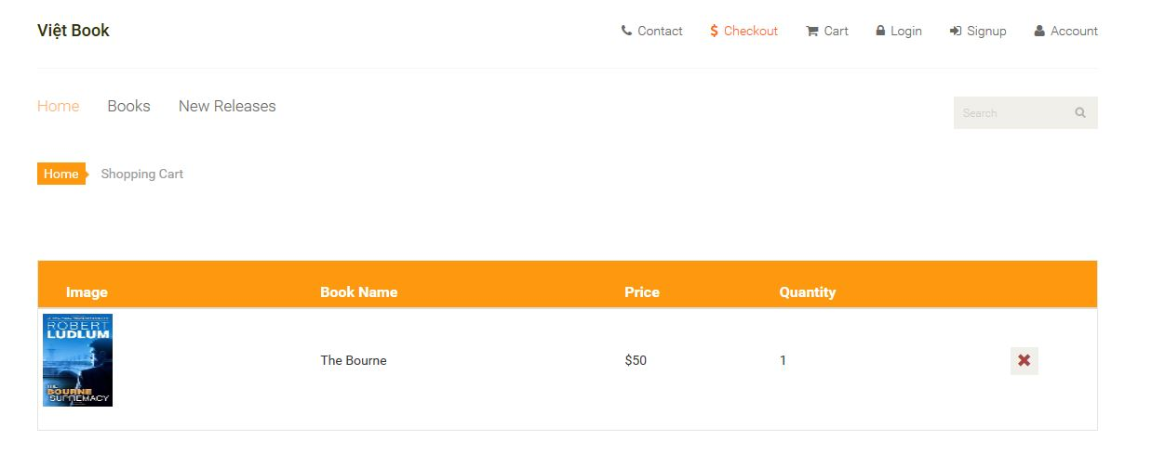

Figure 45: Cart Page

## 4.30 Cart Wireframe Description:

|  |  |  |  |
| --- | --- | --- | --- |
| **#** | **Control Name** | **Control Type** | **Description** |
| 1 | Image | Label | Book image. |
| 2 | Book Name | Label | Book name. |
| 3 | Price | Label | Book retail price. |
| 4 | Quantity | Label | The number of books. |
| 5 |  | Button | Remove the book from the shopping cart. |

## 4.31 Add To Cart Function:

The system provide the shopping cart facility for the user to user during online purchase. If clicking this button:

* The system will automatically add the books into the shopping cart on the Cart page by getting the ID number of the books and pass it to the section of the shopping cart form.
* User can view their buying list of selected books in the Cart page and can freely choose to remove or add more book.
* Every time a new book is added to the cart, the system will automatically update the form in the Cart page.

## 4.32 Quantity Function:

The quantity of each book can be changed accordingly if the user wants to buy the same book more than just one.

The system will save the quantity number of the books into the cart and pass the data to the checkout page once the user has done with selecting their choices of book.

## 4.33 Checkout Wireframe:

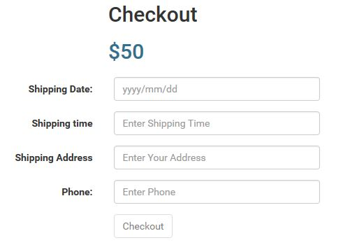

Figure : Checkout Page

## 4.34 Checkout Wireframe Description:

|  |  |  |  |
| --- | --- | --- | --- |
| **#** | **Control Name** | **Control Type** | **Description** |
| 1 | Checkout | Label |  |
| 2 | $50 | Label | Total price of the books that added in the shopping cart. |
| 3 | Shipping Date | Date | Enter the date the shipping takes place. |
| 4 | Shipping Time | Text | Enter the time the shipping takes place. |
| 5 | Shipping Address | Text | Enter the location where the books should be delivered. |
| 6 | Phone | Text | Enter the customer’s phone number. |
| 7 | Checkout | Button | Send the order into the Order database. |

## 4.35 Checkout Function:

The Checkout page is for the user to view the list of the books they have selected to buy before the payment. The system will check when the user enters the checkout form:

* If the user leaves the shipping date input field blank, an error message ”*Please enter the shipping date*” will be showed on the screen.
* If the user leaves the shipping time input field blank, an error message “*Please enter the time you can take your products*” will appear on the screen.
* If the user leaves the phone input field blank, an error message “*Please enter your phone number*” will appear.
* If the user enter a text in the phone input field, an error message “*Please enter the numbers only*” will appear next to the input field.

If the checkout form doesn’t meet any of the error condition mentioned above, a message “You just ordered successfully” will show on top the form and the system server will send the order detail back into the Order database.

The page automatically calculates and sums up the total price of the amount of books presented in the shopping cart section. Then, the said price will be displayed as showed in figure 44.

## 5/ Sign Off

This is the acknowledgement for developing this project.

|  |  |  |
| --- | --- | --- |
| **Name** | **Position** | **Signature** |
|  |  |  |